**De-escalation Stress Model and strategies**

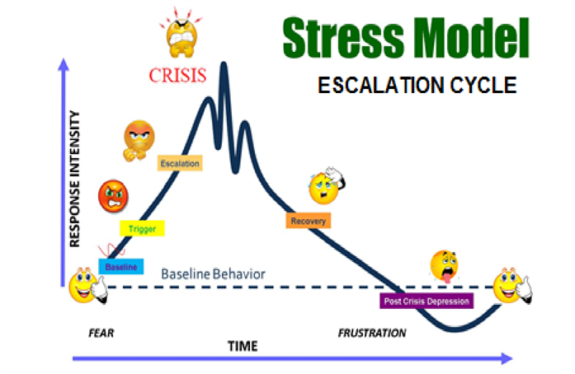

|  |  |
| --- | --- |
| De-escalate:   * Prompt students they will have a few minutes to regroup * Offer acceptable choices * Offer break area/allow space * Ensure all students Safety * If the student leaves, keep visual, notify office, keep student in your line of sight until help arrives. * Remove or reduce contact with triggers * Reduce audience * Teach social skills/conflict resolution * Post expectations * supervision/proximity * stay calm. Stay consistent. Stay fluent. * React unemotionally * Not taking the misbehavior personal   STOIC | Escalate:   * Demand compliance * Take/remove/snatch * Continue talking at/nag * Remind of consequences * Block doors * Attempt to put hands on * Intimidate/instigate by following an agitated student around * Ignored signs of possible tension * Taking sides/quick to blame * Taking it personal * Getting emotionally invested |